Pacy & Wheatley Group
Privacy Policy
Pacy & Wheatley Limited is committed to protecting the privacy and personal data of all individuals we interact with, including clients, employees, subcontractors and suppliers.
This Privacy and GDPR Policy explains how we collect, use, store and safeguard personal data in accordance with the UK Data Protection Act 2018 and the General Data Protection Regulation (GDPR).
How we use your personal information
We will only use your personal information for the following purposes:
- To administer and manage our relationship with you, including to set up and maintain records
e.g., client accounts, supplier accounts and sub-contractor accounts and employee data.
- To process orders for services.
- To deal with enquiries we receive from you.
- For corrective action (during the defects period) when rectification of works may be required.
- To comply with applicable laws, regulations and rules.
- To notify you of changes to what we do.
- To make checks with credit agencies from time to time to ensure financial suitability.
Keeping in touch with you
From time to time, we would also like to keep in touch with you, to provide company updates and details of our services.
We do not share your data with any third parties.

Company’s programme to comply with GDPR:
Pacy & Wheatley will comply with data protection law. This says that the personal information we hold must be:
- Used lawfully, fairly and in a transparent way.
- Collected only for valid purposes that we have clearly explained to you and not used in any way that is incompatible with those purposes.
- Relevant to the purposes we have told you about and limited only to those purposes.
- Accurate and kept up to date.
- Kept only as long as necessary for the purposes we have told you about.
- Kept securely.

IT data Security:
The company will use appropriate technical and organisational measures to keep personal information secure, and in particular to protect against unauthorised or unlawful processing and against accidental loss, destruction or damage.
The company utilises password protection and encryption on Company systems to maintain confidentiality. All access is password protected. Passwords should not be written down or given to

others.
Computers and other electronic devices are timed out to locked when not in use to minimise the risk of accidental loss or disclosure. Confidential information must not be copied onto disk, removable hard drive, CD or DVD or memory stick/ thumb drive without the express permission of a director or the data protection officer. Data copied onto any of these devices should be deleted as soon as possible and stored on the Company’s computer network in order for it to be backed up. All electronic data is securely backed up in accordance with company policy.
Your rights in relation to your personal information
You have various rights under data protection law regarding the processing of your personal information, including rights to:
- Request access to personal information we hold about you and your details of our processing of your personal information.
- Request us to correct inaccurate personal information.
- Request us to delete personal information in certain circumstances.
- Object to the processing of your personal information for direct marketing.
You can make a request to us in relation to these rights at any time by contacting us at enquiries@pacy-wheatley.co.uk. Any information to which you are entitled will be provided within a reasonable timeframe, subject to the exemptions stipulated in applicable date protection laws.
How long do we retain personal information?
We will not keep your personal information longer than is necessary, considering information needed for warranties, applicable legal requirements and limitation periods.
Data Protection training for staff
The Company ensure that staff are adequately trained regarding their data protection responsibilities. Individuals whose roles require regular access to personal information, or who are responsible for implementing this policy or responding to subject access requests under this policy, receive additional training to help them understand their duties and how to comply with them. The training is renewed every 3 years.

How to contact us
If you have any questions about this policy or wish to exercise your GDPR rights, please contact us any time via email at enquiries@pacy-wheatley.co.uk or by calling 01302 760843
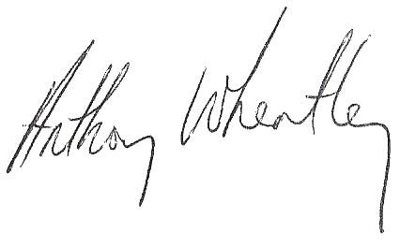
Reviewer: Anthony Wheatley

Date of Review: 24/10/2026 Date of Next Review: 24/10/2027

This policy will be reviewed every 12

